**QA Test Feedback**

**Date: 8th July, 2024**

**Time: 3:00pm**

**QA Tester: Gabriel Ameh**

**WHAT DID WORK**

1. **Downloaded the app**

Feedback: This process worked fine. – verdict PASSED

2. **Installation of the app**

Feedback: This process worked fine. – verdict PASSED

**3. Sign Up**

Feedback: This process worked fine. – verdict PASSED

1. **User Login**

Feedback: This process worked fine. – verdict PASSED

1. **User Log Out**

Feedback: This process worked fine. – verdict PASSED

**TEST REPORT FOR JULY**

**What worked**

**Day 9 to 31**: I was able to see the daily devotion for the days– verdict **– PASSED**

**TEST REPORT FOR AUGUST**

**What worked**

**Day 1 to 30**: I was able to see the daily devotion for the days– verdict **– PASSED**

**What did not work**

**Day 31**: I was not able to see the daily devotion below is the image

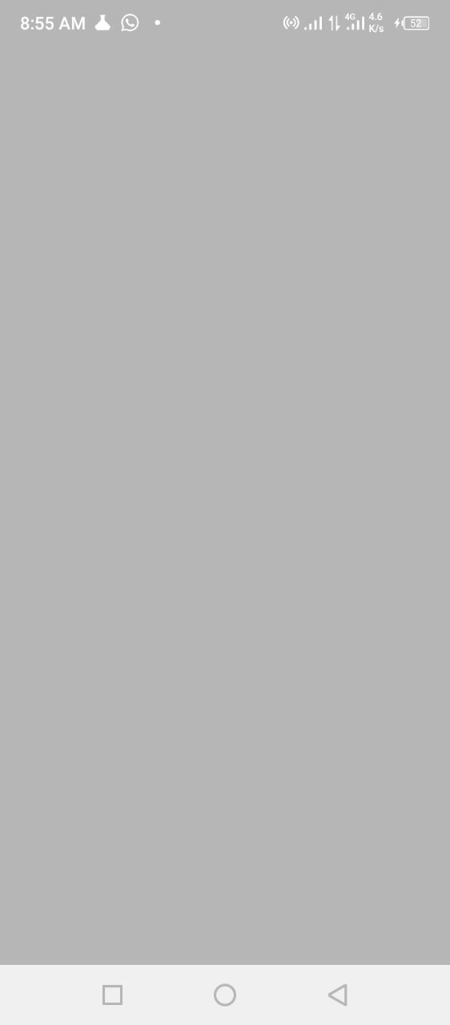

verdict **– Did not PASSED**

**TEST REPORT FOR SEPTEMBER**

**What did not work**

Day 1 to 30: I was not able to see the daily devotion for any of the days below is the image of the result.



verdict **– Did not PASSED**